1. Use the provided Cypher script to create the graph database
2. You could use any names for your project and the graph database
3. Copy the **ENTIRE** Cypher code in the script and paste it in ne4oj$ prompt and then click the blue play button on the right.
4. NOTE in step 15 above that your version may only allow one command at a time.
5. Run the command below. Find the Customer Ashlee Reid and pull the node to the far left of the screen. Include a screen capture of this view to show you were able to load the database**.**

MATCH (n) RETURN (n);

1. Execute the following Cypher code to get the list of retailers: **(0 point)**

MATCH (r:Retailer) RETURN (r);

1. Execute the following Cypher code to the get the list of employees: **(0 point)**

MATCH (e:Employee) RETURN (e);

1. Execute the following Cypher code to the get the list of customers: **(0 point)**

MATCH (c:Customer) RETURN (c);

1. Execute the following Cypher code to the get the list of all disputed transactions: **(0 point)**

MATCH (customer:Customer)-[transaction:SHOPPED_AT]->(retailer) WHERE transaction.status = "Disputed"

RETURN customer.name AS `Customer Name`, retailer.name AS `Retailer Name`, transaction.amount AS `Transaction Amount`, transaction.date AS `Transaction date` ORDER BY `Transaction date` DESC

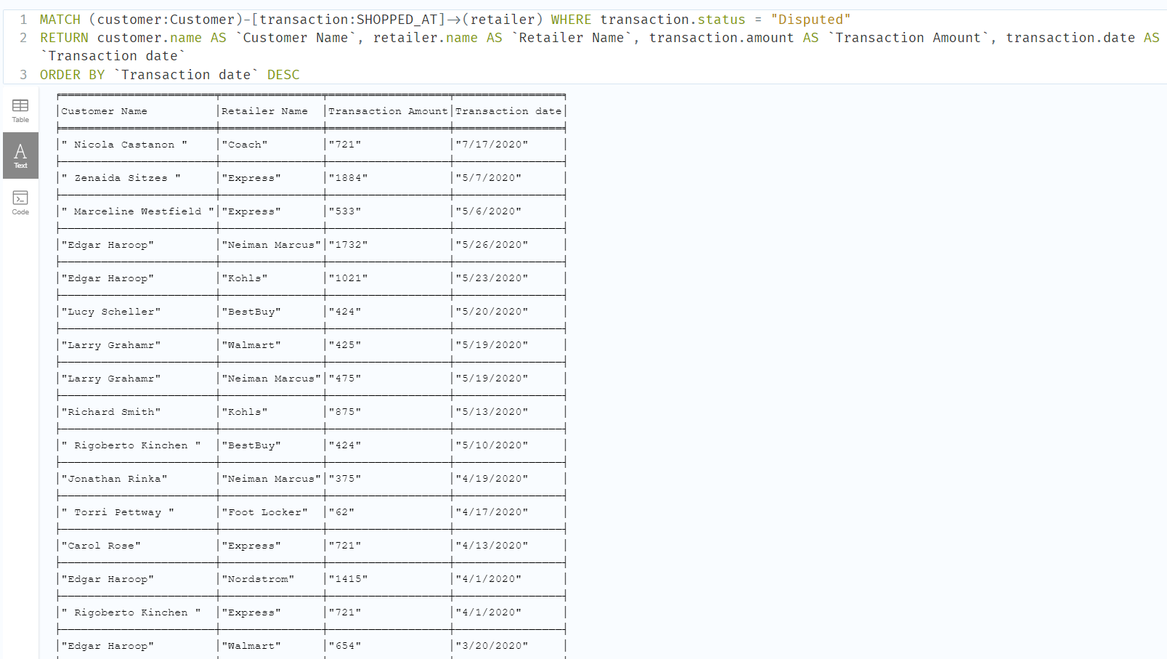

1. Write the Cypher code to get the number of disputed transactions for every retailer. The output should show the Retailer name and the number of disputes. Sort with highest number of disputes on top. **(10 points)**

1. Write the Cypher code to get the number of disputed transactions and the list of customer names for these disputed transactions for every retailer. The output should show the Retailer and the customer name(s). You can consider using a collect() container, but it is not required. **(10 points)**

1. Write the Cypher code to get the number of disputed transactions for every customer that has more than one disputed transaction **(10 points)**

1. Write the Cypher code to get the list of stores on LaSalle Street that have disputed transactions and the number of disputed transactions for every store; the store list must be sorted by store name in ascending order. **(10 points)**

1. Write the Cypher code to get the list of Employees who work in at least 2 stores where disputed transactions reported in these retailers. **(10 points)**

1. Write the Cypher code to show the total amount customers spent shopping at retailers. List the customer’s name and the total amount spent. (**10 points)**

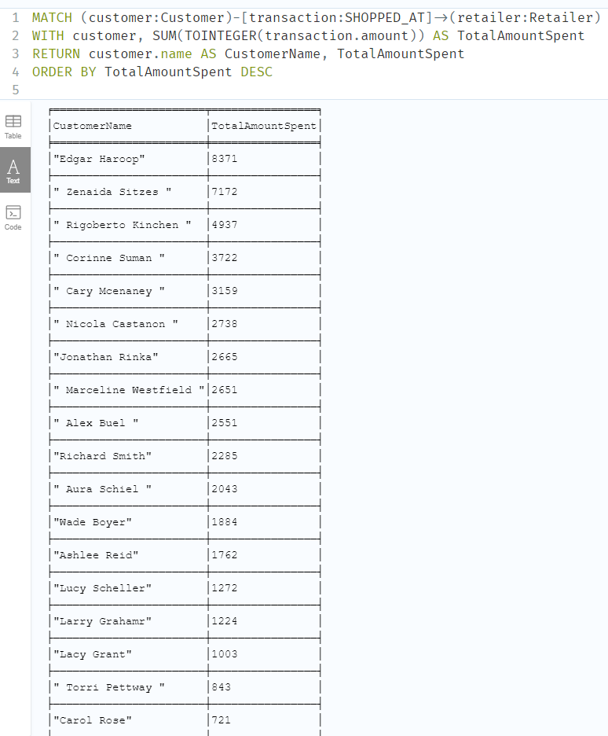

1. Write the Cypher code to show the average amount spent at each Retailer. List the Retailer and the average amount spent. Sort with the highest amount on top. **(10 points)**

